

Are you interested in helping with research?

A study investigating: Understanding language after a stroke
Hello! My name is Holly, I am a speech and language therapist and I’m doing a research project about how people understand language after a stroke. I’d like to know if you are interested in helping with some of my research.



I’m being supervised in my research by Karen Sage, Matt Lambon Ralph and Roland Zahn (all very clever people)!

Karen Sage Matt Lambon Ralph Roland Zahn
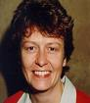

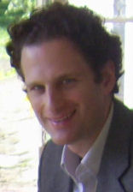

Your speech and language therapist thinks that you might be interested in my research study.

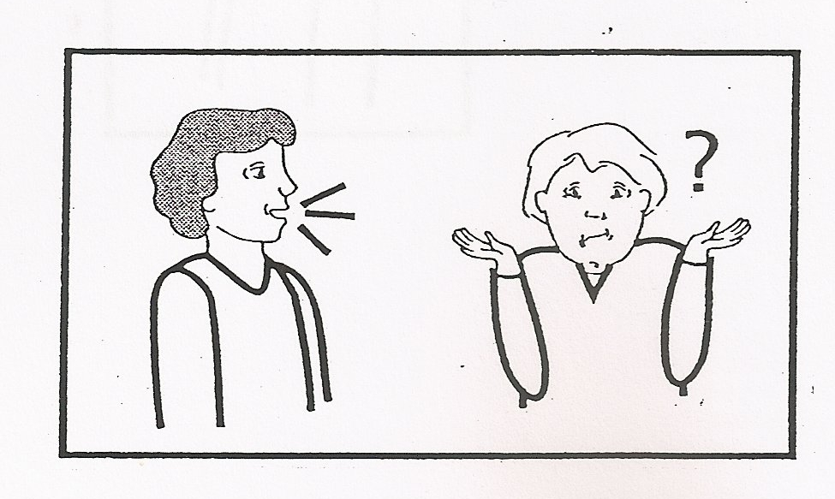
You have been chosen because you have difficulties understanding what other people say


Karen and I would like to come and visit you where you live


We will tell you about our study


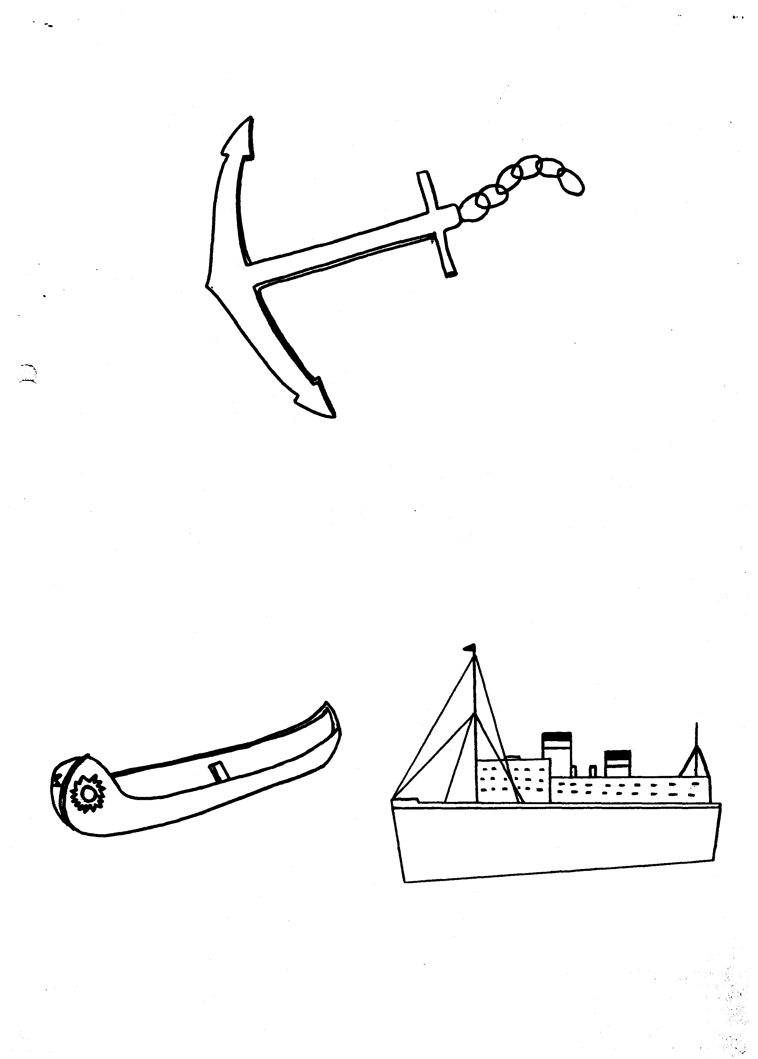
Show you some examples of what you might do if you join the study


And give you some more information

Then we will leave to let you think about whether you would like to take part

Are you interested in meeting us? Tell your speech and language therapist

Neuroscience & Aphasia Research Unit
For more information:
http://www.psych-sci.manchester.ac.uk/students/HollyRobson

